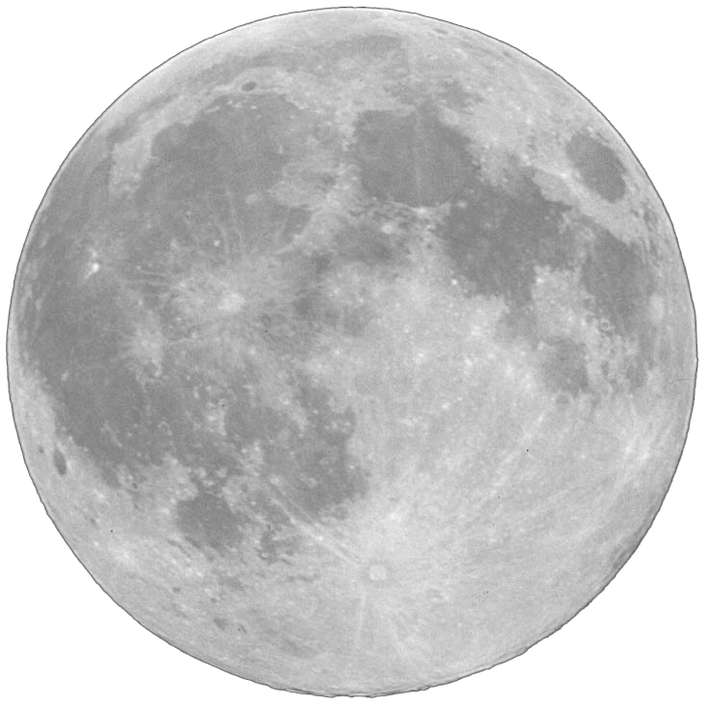
10
20
30
40
50
60
70
80
90
100
110
120
130
140
150
160
170
180
190
200
Miles
Next Speed
Next Speed & Level
Moon Base
Look out for the trap!
Go to the left.
Level increases cause your Rover to bump forward. Be careful!

